<https://www.kia.co.za/assets/images/vehicles/vehicle_16/kia_brochure_sportage.pdf?v=2021>

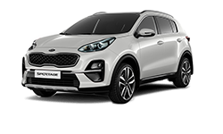

**1.6L GDI IGNITE 2WD Auto**

R 452 995